Graduation Project Guidelines

The graduation project should adhere the following organization and format.

Organization

- Title Page
- Declaration
- Abstract
- Dedication(optional)
- Acknowledgments
- Table of Contents
- List of Tables
- List of Figures
- List of Acronyms/Abbreviations
- Main Body (chapters)
- References
- Appendices (as needed)
- Arabic Summary

The main body of the thesis or project report should be organized according to the following general outline (sequence of the chapters may differ according to the nature of the project):

- Chapter I: Should include a general introduction providing an overview of the topic, problem statement and the project description followed by an adequate scholarly context for subsequent chapters.

- Chapter II: Previous literature related to the topic should be discussed in this chapter. It should constitute the major research effort of the project. Theories and methods examined and their respective implications for the present study should be discussed. Various approaches and themes should be summarized.
- Chapter II: This chapter describes in depth how every aspect of the project was done, compiled, or created. Techniques, questionnaires, interviews, study sites, observations, experiments and material used to accomplish the study should be described here.

- Chapter III: Results of of the work done throughout the project should be elaborated in this chapter. In addition to functional evaluation, this chapter must also include evaluation of the project in terms of (as applicable), but not limited to:

  - Cost
  - Time
  - Environmental impact
  - Manufacturability
  - Ethics
  - Social and Political Impact (if any)
  - Health and Safety
  - Sustainability

- Chapter IV: Conclusions are presented to validate both the need for the study and explain how the present study solved the problem stated.

Any number of chapters could be added according to the nature of problem(s) tackled in the project, yet the above is the minimum requirement of the project.

Format

The following is the format to use for the project documentation (see next page).

Project Title  Subtitle (if any)  Submitted By:  Students Names alphabetically |   Program Name  Graduation Project Report  Supervisor(s)  Date
Image related or represents the project topic

QR | 1 Elsarayat St., Abbaseya, 11517 Cairo, Egypt  Fax: (+20 2) 26850617  www.eng.asu.edu.eg

Declaration
We/I hereby certify that this Project submitted as part of our/my partial fulfilment of BSc in (Name of the Degree) is entirely our/my own work, that we/I have exercised reasonable care to ensure its originality, and does not to the best of our/my knowledge breach any copyrighted materials, and have not been taken from the work of others and to the extent that such work has been cited and acknowledged within the text of our/my work.

Signed: by all students
Name | Signature
Name | Signature
Date: Day, xx Month Year.
Dedication
Optional
Should you choose to include a dedication, it should be centered vertically on the page. If you choose, you may center it horizontally as well, provided that it is no longer than a paragraph. There should be no heading on the dedication page.

Acknowledgment
Use this section to acknowledge the contribution of different people to your work; these may include your supervisor(s), industry partners, sponsors, financial support, specific faculty members in your department, and even your family.

Abstract
The report must begin with a one- to two-paragraph abstract (1 Page) that orients the reader as to the contents as well as to the major sections of the report. The abstract, by itself, must provide enough information about the project so that the reader can judge simply by reading this portion if he or she wants to read further.
For example, as an abstract for this document, this document has been prepared by the Faculty of Engineering to help undergraduate students in preparing their final year project report. The document presents a general outline for these documents as well as the formatting that students must abide to. Also, the exact method for citation and referring to literature related to your work is detailed.
Table of Contents
List of figures ii
list of tables iii
LIST OF ACRONYMS/ABBREVIATIONS iv
1 Introduction 1
2 formatting description 2
2.1 Title Page 2
2.2 General Project Layout 3
2.3 Page and Text Setting 4
2.3.1 Sub-Heading Level 1 5
2.4 Figures and Tables 6
2.4.1 Figure Captions and Table Titles 6
2.4.2 Numbering of Figures and Tables 7
2.4.3 Referring to Figures and Tables in Text 7
2.5 General Recommendations 8
2.5.1 Units 8
2.5.2 Abbreviations and Acronyms 8
2.5.3 Equations 8
2.5.4 Other Recommendations 9
3 citation and referencing 10
3.1 References Format 10
3.2 References to Electronic Sources 12

List of Figures
Figure ‎1-1: Page settings. 4
Figure ‎1-2: Paragraph settings. 5
Figure ‎1-3: Setting caption numbering to include chapter number. 7
Figure ‎1-4: Using Cross-reference. 8

list of tables
Table ‎1-1: List of headings and their formatting. 5

Nomenclature
(As Applicable)

ACRONYM | Definition of Acronym

List Of Utilized Standards
(As Applicable)

Chapter One: Introduction

Basic Criteria:
This document was developed in order to standardize the method of writing final year projects and to fulfill the basic criteria required for the preparation of the projects are as listed below:
- The projects should not entirely depend on information from internet, previous projects or thesis, case studies from literature … etc.
- Images/figures … etc. should be referenced if they are not developed by you.
- The experimentation, if any, should be subject to review of the work done, results obtained, implications, conclusions, reflections … etc.
- The text format should be consistent between chapters and as mentioned in this document.
- The project should contain elements of Design, Analysis activity, development proposal, experimental work or manufacturing elements. Such elements at least must be proposed in Graduation Project 1 in case students will continue working on the same problem in Graduation Project 2.
Chapter Two: Formatting Description
The physical layout and formatting of your final year project report is highly important yet is very often neglected. A tidy, well laid-out and consistently formatted document makes for easier reading and is suggestive of a careful and professional attitude towards its preparation.
In effect, this document has been developed to give you the guidelines for preparing reports for your final year project. Use this document as a template if you are using Microsoft Word. Otherwise, use this document as an instruction set.

Title page
Use the title page as shown previously in this document. Front and back covers fonts used in this document should be followed exactly.

General Project Layout
The report should contain the following components:
- Title or Cover Page.
- Deceleration.
- Dedication (optional).
- Acknowledgements.
- Abstract: a short summary of the project.
- Table of Contents, List of Figures, List of Tables, and List of Acronyms/ Abbreviations.
- Chapters
- Chapter 1, which would be an introduction to the work. A 'Funnel' approach which begins broadly within the topic and concludes the chapter with; focus on what this thesis delivers, and where to find it in the other Chapters.
- Chapter 2 is information gathering or literature review.
- Chapter 3, 4 and 5 (and more if needed) would be specific work carried out and appropriately collated to read well.
- Chapter 6 would be overall Discussion and review/reflection on achievements.
- Chapter 7 would be Conclusions and future recommendations
- References.
- Appendices (optional).

Page and Text Setting
Your project report should be printed (double sided) on good quality A4 80 gms paper. Project reports should be thermal-bound, with cover page coloured 240 gms paper.
Page layout:
- Right Margin: 2.5 cm, Left margin: 3 cm, use mirror margins.
- Top margin: 2.5 cm, bottom margin: 2 cm
- In the header on the right of the page the chapter title should be written in 10 pt Times New Roman font.
- In the footer at the middle page number should be written in 10 pt Times New Roman font.
- Any footnote should in the footer above the page number on the left of the page
- The minimum number of pages for project reports is 50 pages (main report chapters only).
- The body text of the whole document should be in 12 pt Times New Roman font, justified alignment, no indentation for first line in paragraphs, spacing before paragraphs 12 pt, and line spacing set at 1.5 lines; as shown in Error: Reference source not found.

Sub-Heading Level 1
There are different headings and sub-headings that you may find useful in organizing your report; these are summarised in Table ‎2.1.
Table ‎2.1: List of headings and their formatting.
Style Name in Template | Used for | Format
Heading 1 | Chapter title | Times New Roman, Bold, 16 pt., Small Caps, expanded by 3.5, centred, spacing after: 12 pt., and page break before and outline numbered at level 1.
Heading 2 | Main headings | Times New Roman, bold, 14 pt., Title Case, aligned to the left, space before: 6 pt., space after: 6 pt., and outline numbered at level 2.
Heading 3 | Sub-headings level 1 | Times New Roman, bold, 14 pt., Title Case, aligned to the left, space before: 6 pt., space after: 6 pt., and outline numbered at level 3.
Heading 4 | Sub-headings level 2 | Times New Roman, bold, 14 pt., Title case, aligned to the left, space before: 6 pt. and space after: 6 pt.
Heading 5 | Sub-headings level 3 | Times New Roman, bold, 14 pt., Title case, aligned to the left, space before: 6 pt. and space after: 6 pt.
Heading 6 and subsequent headings (not recommended) | Sub-heading level 4 or more | Bullets, times new roman, normal text 12 pt., justified.

Figures and Tables
Use the word “Figure” (“Table”) even at the middle of a sentence when referring to a figure (Table) in text and make sure that all figures and tables are referred to. If your figure has more than one part, include the labels “(a)”, “(b)” … etc. as part of the figure itself (do not use different captions for each figure). Please verify that the figures and tables you mention in the text actually exist.
Do not put borders around the outside of your figures. Do not use color unless it is necessary for the proper interpretation of your figures. When re-sizing your figures, make sure that you use the same percentage for your figures height and width.
Use Times New Roman, 12 pt., aligned to the left, single line spacing and with space before: 6 pt. and space after: 6 pt. The style defined in this template for the text used in tables is “Body Text (Tables)”.

Figure Captions and Table Titles
Place figure captions below the figures; place table titles above the tables. Figure captions should be in Times New Roman, bold, 10 pt., and centered no spacing before or after. Table titles should be in Times New Roman, bold, 10 pt., and centered with no spacing before or after the caption.

Numbering of Figures and Tables
All figures and tables must be numbered in their order of appearance in text. Also, the chapter number must be included in the numbering with a dot separating the chapter number and the figure/table number in that chapter as shown in Error: Reference source not found.
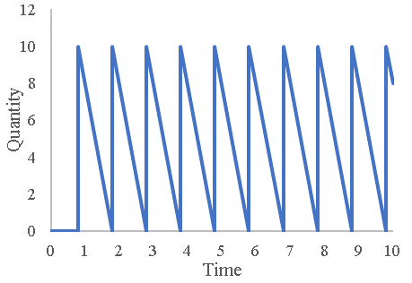  (a) | 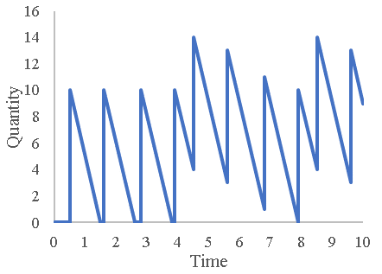  (b)
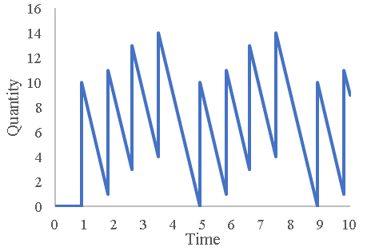  (c) | 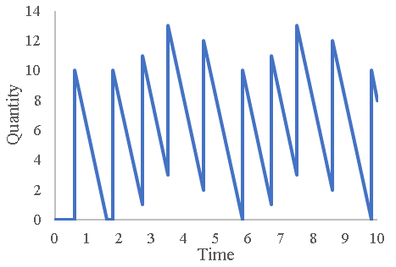  (d)
Figure 2.1. Different cases of inventory at the customer

Referring to Figures and Tables in Text
When referring to figures and tables in your text you can use “Figure 1.1 shows…”, “as shown in Figure 1.1”, “(Figure 1.1)”, or “Table 1.1”.

General Recommendations

Units
Using SI units as primary units are strongly encouraged. English units may be used as secondary units (in parentheses). An exception is when English units are used as identifiers in trade, such as “3½ in disk drive.” Avoid combining SI and English units, as this often leads to confusion because equations do not balance dimensionally. If you must use mixed units, clearly state the units for each quantity in an equation.

Abbreviations and Acronyms
Define abbreviations and acronyms the first time they are used in the text, even after they have already been defined in the abstract. Abbreviations such as SI, ac, and dc do not have to be defined. Abbreviations that incorporate periods should not have spaces: write “C.N.R.S.,” not “C. N. R. S.” Do not use abbreviations in the title unless they are unavoidable.

Equations
Number equations consecutively with equation numbers in parentheses flush with the right margin with the chapter number appears prior to the equation number and separated by dot, as in (1.1). Restart the equations number each chapter. First use the equation editor to create the equation. Then select the “Equation” mark-up style. Press the tab key and write the equation number in parentheses. Use parentheses to avoid ambiguities in denominators. Punctuate equations when they are part of a sentence, as in
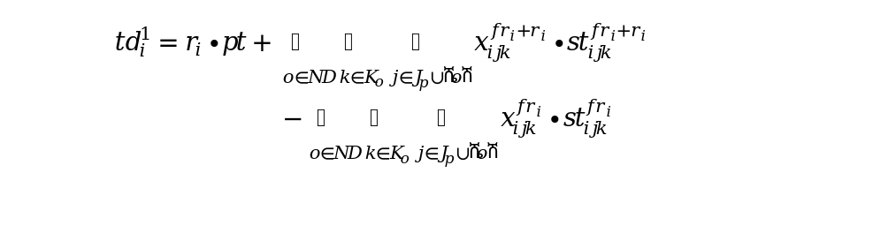 | (1.1)
Be sure that the symbols in your equation have been defined before the equation appears or immediately following. Refer to equations as “Equation (1.1) is…”; even if it is in the middle of a sentence.
For ease of handling equations in the project report document it is recommended to write the equation in table formed of two cells and no borders with the equation in the left cell and the equation number in the right one.

Other Recommendations
Use one space after periods and colons. Hyphenate complex modifiers: “zero-field-cooled magnetization.” Avoid dangling participles, such as, “Using (1.1), the potential was calculated.” [It is not clear who or what used (1).] Write instead, “The potential was calculated by using (1.1),”
Use a zero before decimal points: “0.25,” not “.25.” Use “cm³,” not “cc.” Indicate sample dimensions as “0.1 cm × 0.2 cm,” not “0.1 × 0.2 cm².”
Do not mix complete spellings and abbreviations of units: use “Wb/m²” or “webers per square meter,” not “webers/m².”
When expressing a range of values, write “7 to 9” or “7-9,” not “7~9.”
A parenthetical statement at the end of a sentence is punctuated outside of the closing parenthesis (like this). (A parenthetical sentence is punctuated within the parentheses.) In American English, periods and commas are within quotation marks, like “this period.” Other punctuation is “outside”!
Avoid contractions; for example, write “do not” instead of “don’t.”
If you wish, you may write in the first person singular or plural and use the active voice (“I observed that ...” or “We observed that ...” instead of “It was observed that ...”). However, passive voice is preferred.
Remember to check spelling.
Chapter Three Citation and Referencing
The report should be based on the student’s own work and in case of using any parts or copying any figures or diagrams from previous work this should be properly referenced according to the format explained below.
A numbered list of references must be provided at the end of the paper. The list should be arranged in the order of citation in text, not in alphabetical order. List only one reference per reference number.
Each reference number should be enclosed by square brackets. In text, citations of references may be given simply as “in [1] . . .” rather than as “in reference [1] . . .” Similarly, it is not necessary to mention the authors of a reference unless the mention is relevant to the text. It is almost never useful to give dates of references in text. These will usually be deleted by Staff Editors if included.
Footnotes or other words and phrases that are not part of the reference format do not belong on the reference list. Phrases such as “For example,” should not introduce references in the list, but should instead be given in parentheses in text, followed by the reference number, i.e., “For example, see [5].”

References Format
Sample correct formats for various types of references are as follows.
Books:
- G. O. Young, “Synthetic structure of industrial plastics,” in Plastics, 2nd ed., vol. 3, J. Peters, Ed. New York: McGraw-Hill, 1964, pp. 15–64.
- W.-K. Chen, Linear Networks and Systems. Belmont, CA: Wadsworth, 1993, pp. 123–135.

Periodicals:
- J. U. Duncombe, “Infrared navigation—Part I: An assessment of feasibility,” IEEE Trans. Electron Devices, vol. ED-11, pp. 34–39, Jan. 1959.
- E. P. Wigner, “Theory of travelling-wave optical laser,” Phys. Rev., vol. 134, pp. A635–A646, Dec. 1965.
- E. H. Miller, “A note on reflector arrays,” IEEE Trans. Antennas Propagat., tobe published.
Articles from Conference Proceedings (published):
- D. B. Payne and J. R. Stern, “Wavelength-switched passively coupled single-mode optical network,” in Proc. IOOC-ECOC, 1985, pp. 585–590.
Papers Presented at Conferences (unpublished):
- D. Ebehard and E. Voges, “Digital single sideband detection for interferometric sensors,” presented at the 2nd Int. Conf. Optical Fibre Sensors, Stuttgart, Germany, 1984.
Standards/Patents:
- G. Brandli and M. Dick, “Alternating current fed power supply,” U.S. Patent 4 084 217, Nov. 4, 1978.
Technical Reports:
- E. E. Reber, R. L. Mitchell, and C. J. Carter, “Oxygen absorption in the Earth’s atmosphere,” Aerospace Corp., Los Angeles, CA, Tech. Rep. TR-0200 (4230-46)-3, Nov. 1968.

References to Electronic Sources
The guidelines for citing electronic information as offered below are a modified illustration of the adaptation by the International Standards Organization (ISO) documentation system and the American Psychological Association (APA) style. Three pieces of information are required to complete each reference: 1) protocol or service; 2) location where the item is to be found; and 3) item to be retrieved. It is not necessary to repeat the protocol (i.e., http) in Web addresses after “Available” since that is stated in the URL.
Books:
- J. Jones. (1991, May 10). Networks. (2nd ed.) [Online]. Available: http://www.atm.com
Journals:
- R. J. Vidmar. (1992, Aug.). On the use of atmospheric plasmas as electromagnetic reﬂectors. IEEE Trans. Plasma Sci. [Online]. 21(3), pp. 876–880. Available: http://www.halcyon.com/pub/journals/21ps03-vidmar
Papers Presented at Conferences:
- PROCESS Corp., MA. Intranets: Internet technologies deployed behind the firewall for corporate productivity. Presented at INET96 Annu. Meeting. [Online]. Available: http://home.process.com/Intranets/wp2.htp
Reports and Handbooks:
- S. L. Talleen. (1996, Apr.). The Intranet Architecture: Managing information in the new paradigm. Amdahl Corp., CA. [Online]. Available: http://www.amdahl.com/doc/products/bsg/intra/infra/html
Computer Programs and Electronic Documents:
- A. Harriman. (1993, June). Compendium of genealogical software. Humanist. [Online]. Available e-mail: HUMANIST@NYVM Message: get GENEALOGY REPORT

